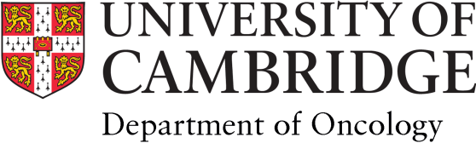
Annual Leave Request
1 October 2020 to 30 September 2021

Name: | Email:

Period of Leave - Inclusive |  | Leave Entitlement:
Start Date | End Date | Half Days  Specify  am or pm | Total Days Taken | Total Days Remaining | Line Manager’s  Signature | HR Rec.

Return completed form by email to: OncologyHR@admin.cam.ac.uk
Please re-use the same form each time you request leave and do not send paper copies.

All annual Leave queries to: OncologyHR@admin.cam.ac.uk

