

DSE and Ergonomics Self-Assessment form

Please return completed questionnaires to:
Laura Turner at:

Email: oncsafe@hermes.cam.ac.uk

Post: Office 4.22, Level 4,
Hutchison/MRC Research Centre
Box 197
Cambridge Biomedical Campus
Cambridge
CB2 0XZ

The form is primarily concerned with working with Display Screen Equipment, but is designed to include your entire work areas, e.g. Microscopy, Microinjection, Tissue Culture, Cryostat work and Pipetting. It contains the following sections:

- Section 1: Your contact details

- Section 2: For you to provide information about your use of DSE, which to determine whether you require a full DSE assessment.

- Section 3: Confirms that you have provided the information given on the form.

- Section 4: The Departmental Safety Officer adds their decision about whether you need a full DSE assessment

- Display Screen Equipment Checklist: Contains basic information and checklist to ensure you are working safely with Display Screen Equipment and laptops.

Please take a few minutes to complete this questionnaire so that I am aware of your work pattern so that I can provide you with guidance for safer working and provide you with a full DSE assessment.

Display Screen Equipment

The Health and Safety (Display Screen Equipment) Regulations 1992 require the ‘users’ of Display Screen Equipment (DSE)*, eg computers, are assessed to minimise the risk of injury caused by inappropriate use of the DSE and other associated equipment.

Any alphanumeric or graphic display screen, regardless of the display process involved is classed as DSE. Indirectly, this also includes the ‘workstation’ around the DSE – optional accessories to the DSE, disk drive, telephone, modems, printers, document holders, work chair, work desk, work surface or other items peripheral to the DSE, and the immediate work environment around the DSE

Ergonomics

What do we mean by human factors/ergonomics? HSE has defined human factors (also known as Ergonomics) as the environmental, organisational and job factors, and human and individual characteristics which influence behaviour at work. Careful consideration of human factors can improve health and safety by reducing the number of accidents and cases of ill-health at work. It also provides considerable benefits for business by reducing the costs associated with such incidents and increasing efficiency.

Department of Oncology DSE Assessment Form

Section 1

Name (please print):

Line Manager:

Location:

Email: Tel:

Start date of contract/visit:

Expected end date of contract/visit: _________________________________________________

If you NEVER use DSE – tick this box please go to Section 3. sign, date and return the questionnaire

If you do use DSE – please complete Sections, 1, 2 and 3.

Section 2

Dependency | You depend on the use of display screen equipment (DSE) to do the job | High | Medium | Low
Discretion / flexibility | You can decide when you use the DSE and when you do other tasks | Rarely | Sometimes | Usually
Prolonged Spells >1hr | You normally use the DSE for continuous spells of an hour or more at a time | More or less daily | Weekly | Rarely
Constant Use | When you are using the DSE, how much of the day is normally spent on it | More than 4 hours | 2-4 hours | Less than 2 hours
Significant training | You need significant training and / or particular job skills in the use of DSE to do the job | Yes | No
Headaches | You experience headaches while using the DSE | Frequently | Occasionally | Infrequently or Never
Visual problems | You experience eye problems, fatigue or strain when using the DSE | Frequently | Occasionally | Infrequently or Never
Fatigue and Stress | Using your DSE increases the amount of stress or fatigue you are feeling | Frequently | Occasionally | Infrequently or Never
Do you experience any Musculoskeletal Problems when using the DSE? |  | Frequently | Occasionally | Infrequently or Never
If yes, please explain the nature of your problem

Position of Workstation | Office-Based Lab-Based
What are the hours of work for a typical day?
(e.g. 9am –6pm)

What formal breaks occur during the day away from the workstation? | Break (am) - Yes/No (delete as appropriate)  Lunch - Yes/No (delete as appropriate)  Break (pm) - Yes/No (delete as appropriate)
Do you use/do you intend to use a laptop as your main computer? | Yes/No (delete as appropriate)
Do you currently have a laptop stand? | Yes/No (delete as appropriate)
Time spent on particular activities on an average day
   | Frequency (e.g. daily) | Duration (hrs)
  Desk work
  Display Screen Equipment
  Tissue Culture
  Microscopy/Microinjection
  Pipetting
  Cryostat
  Manual Handling

Any other information which could be useful

Section 3

Signature:

Date:

Section 4

Office Use Only

Questionnaire Received: ______________________

Priority Assessment
 | 1 Point | 3 Points | 5 Points | Points
Discretion/flexibility | Rarely | Sometimes | Usually
Prolonged Spells | More or less daily | Weekly | Rarely
Constant Use | More than 4 hours | 2-4 hours | Less than 2 hours
 |  |  | Total Points

(1-5 High 6-10 Medium 11-15 Low)

Priority for Assessment: High Medium Low Signed: _________________


Display Screen Equipment (DSE) Check List

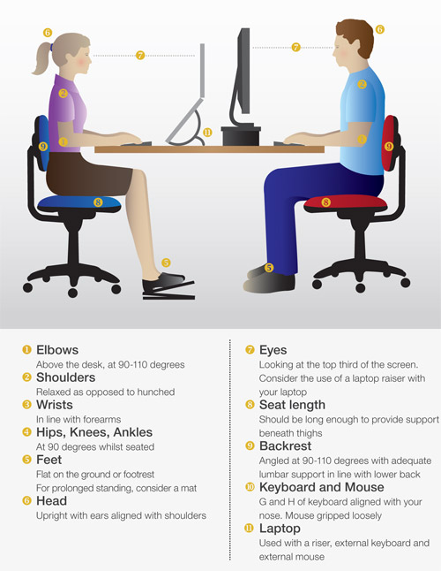

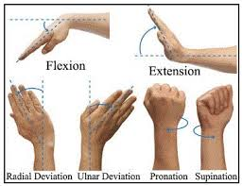

Seating and Posture  - Completely relax your shoulders, keep your upper arms by your sides and your forearms horizontal.  - Raise or lower your chair so this position can be maintained whilst you use your keyboard with straight (neutral) wrists.  - If your feet do not touch the floor now, or there is excess pressure on the backs of your knees/thighs, you may require a foot stool/rest.  - Sit right back into your chair, adjust the height and tilt of the chair back to obtain support and make use of the lumbar support area.  - Chair arms may need removing to ensure that it tucks under the desk. | 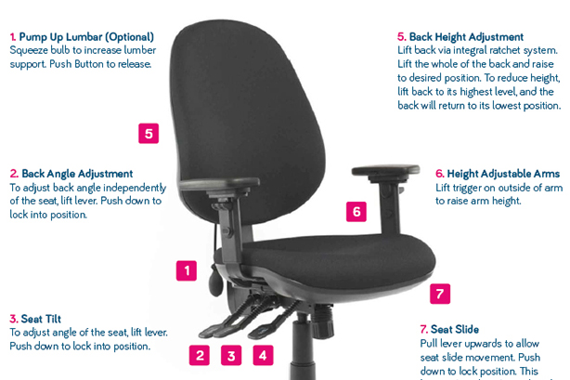
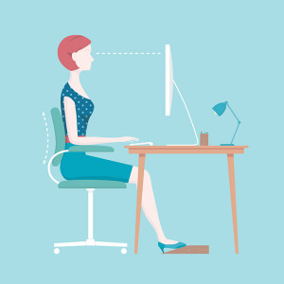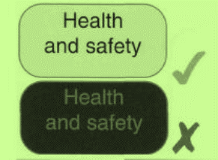 | The Screen  - Adjust screen height and tilt to allow a comfortable straight neck position.  - Your screen should be straight in front of you, at about arm’s length away and with your eyes level with the top of the screen.  - If you do not touch-type the screen may be more comfortable in a lower position.  - Position your screen to avoid any glare and reflections. Blinds on windows may need adjusting.  - Adjust the brightness, contrast and text size so comfortable.
The Keyboard  - This should allow enough space in front of you to support your wrists/forearms when not typing.  - Use a soft light touch when typing. | 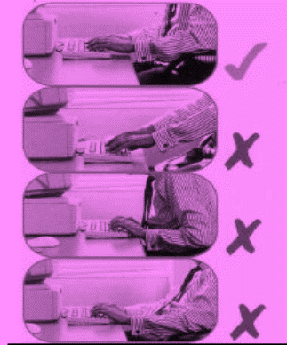
The Mouse  - Keep the mouse as close to your body as possible and your arm relaxed.  - Do not overstretch or bend your wrists awkwardly when using the mouse.  - Alternate the mouse between your left and right hand if possible.  - Use keyboard shortcuts.  - Consider software to reduce the amount of clicking. | 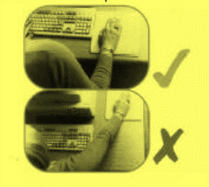
Rest Breaks (MOST IMPORTANT)  - Short frequent breaks are better than  - occasional longer breaks.  - Aim for at least 5-10 minutes’ break  - following 50-60 minutes continuous  - computer work.  - Consider break monitoring software.  - Alternate tasks for natural breaks.  - Gentle exercises and stretches during breaks will help relieve muscle tension.  - If using your computer all day, take a break away from it for at least twenty minutes at lunchtime. Go out for a walk if possible. | Other  - Document holders placed at screen height or between the screen and keyboard, are useful if typing from hardcopy documents.  - Headsets are vital if you regularly type whilst talking on the telephone.  - Consider software training and learning to touch type to improve your speed and keyboard skills.  - Have enough space both on and under your desk.  - Keep all your computer equipment clean.

Please contact Laura Turner with any problems after you have completed the checklist at oncsafe@hermes.cam.ac.uk

